GTB  
  
**QA**  
[DEV 20.14] OT-843 | XT | FR | AS | Contact a Dealer Popin v1 – 7 April 2020

**Jira ticket:**  
<https://jira.uhub.biz/browse/GTBEMEAOPT-843>

**Site**  
<https://www.ford.fr/>

**Test location**  
All pages except on BnP

**Hypothesis**  
Analysis on the TDR Popin and UC5 has shown that TDR Popin converts at a higher rate than UC5 for TDR Completes. We know that we can expect the conversion rate to be 100% higher than onsite conversion. As such, we want to ensure we keep leveraging this popin and its audience even during the pandemic. However, we will be shifting our focus to "Contact Us" to maintain a touch-free approach.

**Test Description**

**NOTE:** This activity does not run in Incognito.

View the BnP Start and Finish link. Click on the "Configurateur” link in the main heading. On the left there’s an option to pick "Voitures neuves” or “Utilitaires & Pick-up” ~ Select vehicles from both sides.  
  
Next view the “Only on profile script true” link. After 10 seconds a popup should appear.

If the vehicle you viewed is from the “Voitures neuves” option and not a “Ranger” the popup that appears should look something like the below.

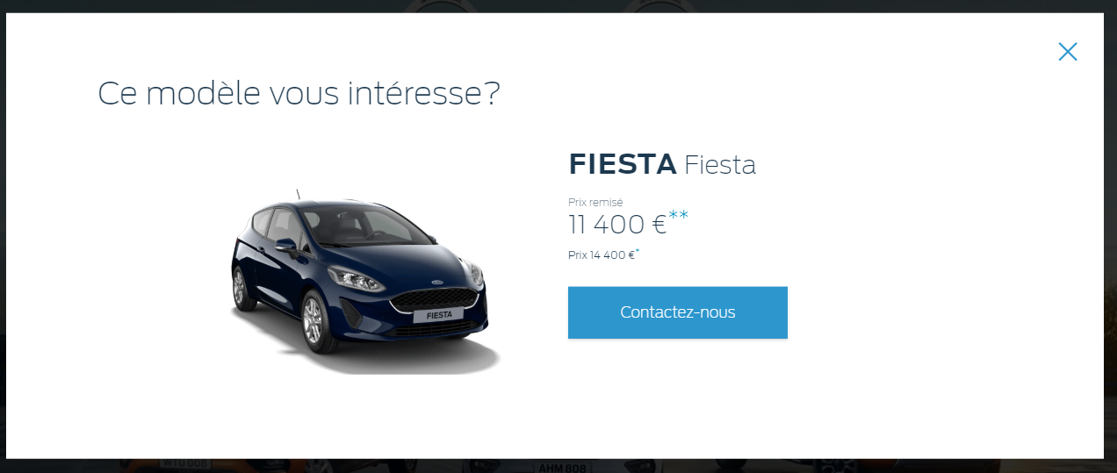

When you click on the “**” or the “*” links a smaller popup should appear that looks like the below two images:

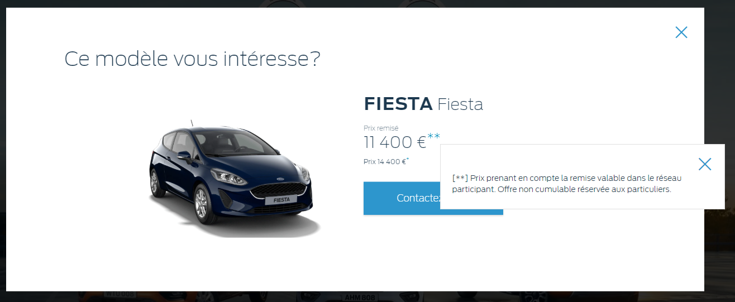

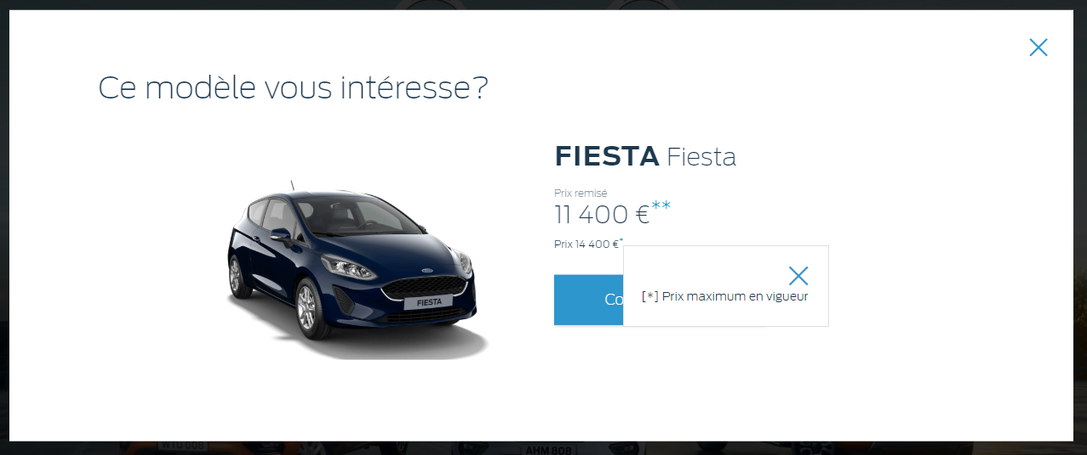

If the vehicle you viewed is a Ranger or from the “Utilitaires & Pick-up" option, the popup should look like the below:

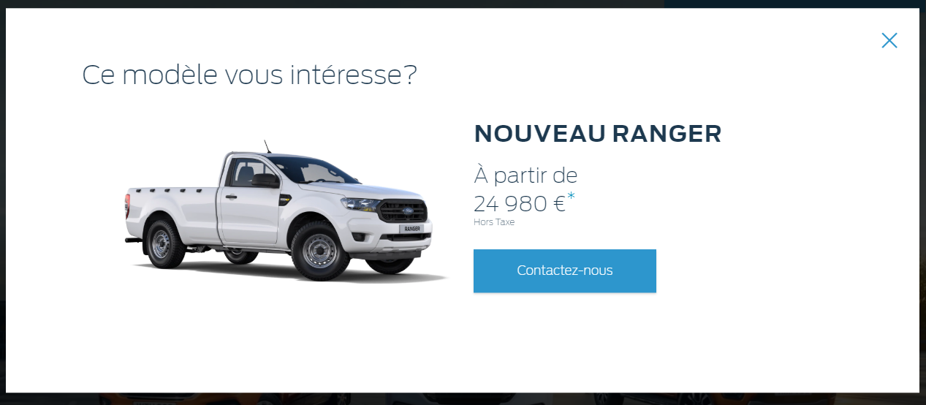

When you click on the “*” link a smaller popup should appear that looks like the below:

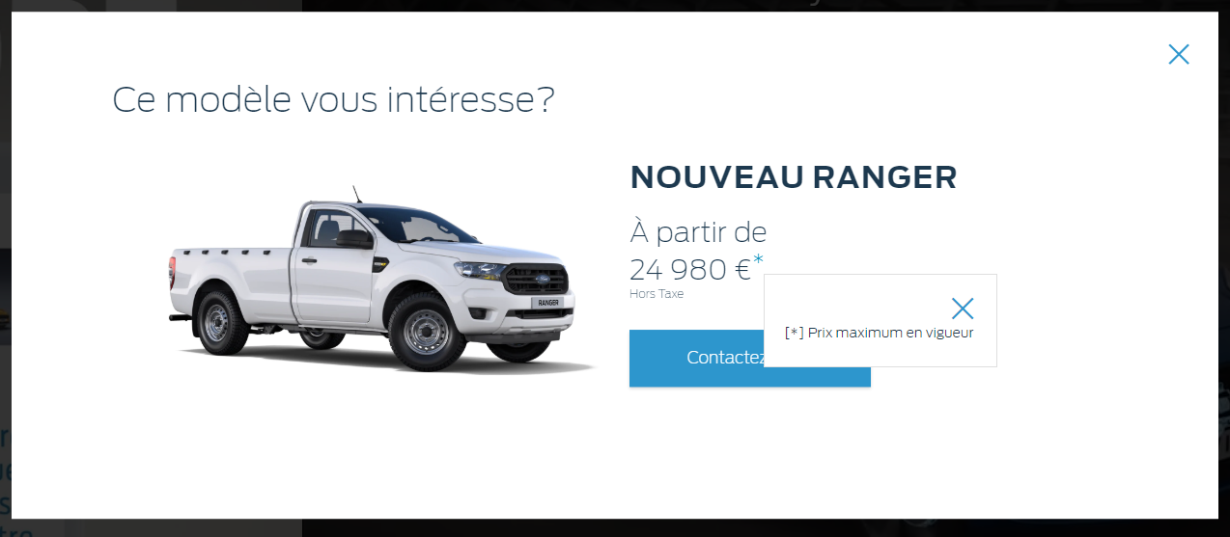

**Browser:**   
All  
  
**Device:**   
All  
  
**Audience rules:**   
All traffic

**QA Links:**

BnP Start and Finish:

<https://www.ford.fr/?at_preview_token=x7%2BEqGE4bK83WLbrtL8Nbg%3D%3D&at_preview_index=1_1&at_preview_listed_activities_only=true>

Only on profile script true:

<https://www.ford.fr/?at_preview_token=x7%2BEqGE4bK83WLbrtL8Nbg%3D%3D&at_preview_index=1_2&at_preview_listed_activities_only=true>

TDR Drive Link:

<https://www.ford.fr/achat/poursuivre-lexperience/demande-d-essai>